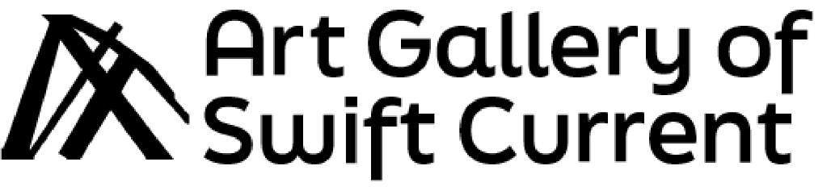
411 Herbert St E.
Swift Current, SK
S9H 1M5
(306) 778-2736
Call for Art Educators!
We are seeking experienced, self-motivated, art-loving instructors to support our community in developing their art skills! We hope to find multiple instructors who specialize in different types of media to instruct art classes and workshops for children, youth, and/or adults.
These are contracted, casual, work-as-needed positions.
Art Gallery of Swift Current offers art classes throughout the year, across a range of mediums. Classes take place at Dickson Community Centre on 751 Lorne St West. AGSC has several fully equipped classroom studios suitable for a variety of programs.
While we are eager to accept applications from instructors specializing in all types of media, we are especially seeking artists who specialize in some of the following mediums:
- Sculpture
- Fibre art
- Felting
- Drawing
- Printmaking
- Mosaics
- Plein air oil painting or water-based oil paints
- And more!
Applicants must:
- Have a reliable method of transportation
- Be willing to become Youth Certified
- Be able to work with minimal supervision/minimal assistance
- Have some previous teaching experience
- Be willing to create their own lesson plans
- Be willing to work with participants from all walks of life
- Have a passion for the arts

Desirable qualifications:
- Bachelor’s degree in art or a related discipline

AGSC provides:
- Class administration
- Fully equipped classroom studios
- Equipment and materials for each participant
- Youth Certified training
- Assistance with classes as needed and within staff capacities

Compensation:
$45/hr for teaching time
$25/hr for prep. This includes class preparation, set-up, and cleanup.
Mileage is offered for instructors who reside outside of city limits.
To Apply:
Please Send your CV and cover letter, along with 2 references to m.flaterud@swiftcurrent.ca

